June 2023
Pornography Use Among Young Adults in the United States
Sam Smith Nelson and Jamie LeSueur

Summary
Pornography exists in many forms across the internet including pictures, videos, audio, written materials, video games, and social media posts. A majority of the US population has intentionally viewed pornography before, with an even larger majority of US young adults viewing pornography regularly. Despite the widespread use of and support for pornography, viewing sexually explicit media can have many negative consequences. For example, pornography use has been shown to correlate with decreased sex-life satisfaction, lack of positive self-image, and increased chances of divorce. Research also shows that both pornography viewers and pornography actors are likely to experience emotional health consequences. Two of the reasons people consume pornography so frequently are because the content has addictive properties and because it is widely marketed on the internet and therefore easily accessed. Likewise, the pornography industry generates massive amounts of revenue, which continually fuel the creation and advertising of new pornography. While there are many resources available to combat pornography use, the main practice to decrease pornography is to publicize its negative consequences and alert people to the risks they assume when they view sexually explicit content.

Key Takeaways
- Pornography exists on 12% of all websites¹ and is viewed by approximately 69% of American men and 40% of American women in any given year.²
- Support and public opinion for pornography have increased among young adults in the last several decades.³
- One reason for the creation and circulation of pornography is the lucrative nature of the industry—in 2023 the Adult & Pornographic Websites industry in the United States was on track to match the revenue of the NCAA at $1.15 billion.^{4,5}
- Using pornography correlates with decreased sex-life satisfaction,⁶ increased desire for rough or violent sex,⁷ and increased chances of divorce.⁸
- Adult film performers face a range of challenging issues including mental and emotional well-being (such as depression, eating disorders, and even suicide), financial struggles, physical and sexual health risks (including STDs and body modifications), strained relationships, and the distressing reality of systematic support for sexual abuse and rape.
- Pornography is often overlooked largely due to the prevailing pro-porn sentiment among the general public. However, research confirms the negative consequences, and organizations are emerging to combat what has been deemed as the “porndemic.”⁹

Key Terms
Addiction—“Compulsive, chronic, physiological or psychological need for a habit-forming substance, behavior, or activity having harmful physical, psychological, or social effects and typically causing well-defined symptoms."¹⁰
Adult Film Performers—Refers to an individual who is paid to act in pornography films.
Amateur Porn Stars—“Non-professionals performing with little pay, or actors for whom this material is not their only paid modeling work.”¹¹
Incentive Salience—A theory about brain function particularly relevant in describing the neural patterns of addicts. The theory suggests that “it is possible to ‘want’ what is not expected to be liked, nor remembered to be liked, as well as what is not actually liked when obtained.”¹²
Obscenity—A US legal term for “lewd, filthy, or disgusting words or pictures.” Each state has different laws defining what is considered obscene.¹³
Pornhub—One of the largest websites dedicated to publishing pornography. The site is owned by a larger company called MindGeek.¹⁴
Porn stars—Jargon referring to a person who is famous for starring in pornographic films.¹⁵ The term usually references adult film performers, as opposed to amateur or independent pornography creators.
Pornography—“Sexually explicit media that are primarily intended to sexually arouse the audience.”¹⁶
Sexually explicit—“Sexually explicit means a pictorial depiction of actual or simulated sexual acts including [but not limited to] sexual intercourse, oral sex, or masturbation.”¹⁷
Sexual scripts—Learned ideas about sex that “suggest what events should and should not be happening, how people should behave in response to what is or is not happening, and what the outcomes of particular courses of action should be.”¹⁸

Context

Q: What is classified as pornography?
A: A: “Pornography refers to sexually explicit media that are primarily intended to sexually arouse the audience.”¹⁹ Pornography exists in many forms, most commonly pictures and videos of barely clothed or completely nude individuals engaging in sexual behavior. It also exists in the form of written material, electronic images, video games, social media posts, phone apps, erotic telephone conversations, music, or any other medium.²⁰ Anything containing detailed descriptions of sexual organs or the emotions and feelings associated with sex can be considered pornographic.
It has been found that there are nearly as many definitions for sexually explicit material as there are individuals who have studied it.²¹ Every culture and religion holds a different set of standards for defining pornography,²² posing a challenge to describing and researching pornography as a social issue. For the purpose of this brief, we will align with the definition aforementioned.
There are multiple levels of pornography usage. Having a pornography habit and a pornography addiction is not the same thing; people can use pornography casually without becoming addicted.²³ However, some pornography users engage in a level of compulsive viewing that can be considered an addiction.

Q: Why focus on the United States instead of a different region?
A: Because pornography is predominately accessed online, it is equally on hand to anyone with an internet connection, regardless of what nation they live in. Studies show that rates of pornography use are relatively comparable among developed nations—for example, results from 2 separate surveys, 1 in Australia and 1 in the US, can be taken together to conclude that 70–80% of men and 32–42% of women in both nations watched pornography in the last year.^{24,25} Similarly, surveys in Sweden and the US report that 5–11% of people watch pornography every day.^{26,27} While there are discrepancies in pornography consumption across the nations, we have not found research showing that one developed nation consumes pornography at a significantly higher rate than any other nation.
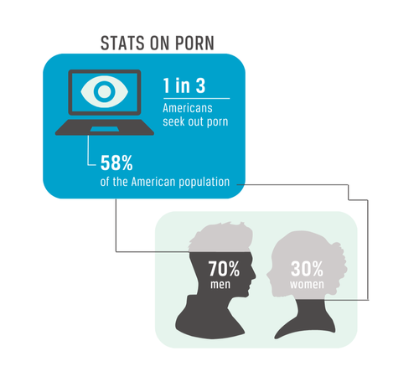
However, the statistics on pornography specifically in the United States are worth noting. According to one website, Pornhub is the fourth most visited website in the United States behind Google, Youtube, and Facebook. Pornhub totaled over 2.14 billion visits during a single month in 2023—more than Instagram, Netflix, Pinterest, and Tiktok combined.²⁸ Data from the National Library of Medicine has called pornography use in the United States a “porndemic.”²⁹
Although pornography impacts a large sum of countries throughout the world, this brief will focus on pornography use in the United States. By studying a single nation, we can better synthesize the massive amounts of research and present a thorough case that can then be related to other countries.

Q: What is the public view of pornography in the US?
A: One survey found that Americans ages 13 and older consider content pornographic if it is sexually explicit, displays sexual intercourse, displays sexual acts, is intended for the arousal of the viewer, or contains full nudity.³⁰ Regarding personal feelings for or against pornography, a separate study from 2019, showed that 14% of Americans agree or strongly agree that pornography is morally wrong, while 51% disagree or strongly disagree.³¹ These statistics give a good general sense of America’s opinion, but perceptions vary according to age and gender. One study shows that young adults and men are generally more likely than their older or female counterparts to support pornography staying legal.³¹ When asked if individuals believed pornography is “very bad” for society, 37% of baby boomers agree, whereas only 14% of today’s young adults agree, which reveals a 23 percentage point decrease between the generations. This margin holds true when comparing men’s and women’s answers regarding the same question: 21% of men agree that pornography is “very bad” while 39% of women agree.³³ A previously cited study shows that public perception has swung more in favor of pornography in the last 40 years. In the 1970s, an average of 29.6% of men and 45.2% of women believed that pornography should be illegal. In 2012, those percentages dropped to 18.4% and 35% respectively.³⁴
Support for pornography may be fueled (at least partially) by professed positive outcomes by individuals who watch pornography. For example, participants in some studies report that pornography has helped them develop positive, confident sexual identities.³⁵ Regardless of whether a person professes positive or negative outcomes from their pornography use, 11% of American men and 3% of American women self-reported in 2019 that they considered themselves addicted to pornography.³⁶
Concerning child pornography, 84% of the US public believes that viewing child pornography is not the same as viewing adult pornography and that it should be illegal.³⁷ This sentiment aligns with current laws—according to the United States Department of Justice, disseminating “obscenity and child pornography, whether through the internet or any other means, is illegal under federal law for adults and juveniles.”³⁷ Besides prohibiting child pornography, most state laws also have statutes that prohibit the dissemination of pornography depicting nonconsensual sex, or rape,³⁹ and the dissemination of pornography that was consensually filmed but not consensually posted.⁴⁰
Current US laws pattern after the public opinion of its populace. The law prohibits the selling, distribution, transportation, shipping, mailing, and production with intent to distribute, sell, or engage in a business of selling or transferring obscene matter. But as it currently stands, most adult pornography is not considered obscene. It is the public opinion regarding what is classified as obscene that makes pornography legal or not;⁴¹ therefore, as public opinion becomes more accepting, the local and federal laws become more lenient. A US citizen is legally permitted to watch pornography, but in some cases, possession of illegally distributed obscene pornography can result in prosecution. However, since the Reagan and Bush administrations, the Department of Justice (DOJ) has not opened a new adult obscenity case against a major commercial distributor of “adult” obscenity for more than a decade.⁴²

Q: Who is the demographic this issue affects?
A: Pornography use is not limited by demographics; it is used by many people of varying ages, races, genders, and sexual orientations around the United States. Because of this, the percentages of pornography users in the United States look different in every study. But to give a general idea, one study shows that 58% of Americans have watched pornography at least once in their lifetime, and 27% watched it in the past month.⁴³ Another says that 1 out of 3 Americans seek porn at least monthly.⁴⁴
But very little research categorizes pornography viewership into one conglomerate; instead, viewership is typically divided by demographics, which produces a few stark trends. For example, gender is a strong predictor of whether a person has viewed pornography, with men being more likely than women. One study concluded that men are approximately 20% more likely to download or view pornography than women;⁴⁵ another found that in a given year, 69% of men reported having viewed pornography and 40% of women.⁴⁶ Trends in pornography usage also correlate with younger audiences. In the United States, a survey found that the most active pornography users are 18–34 years old. It also showed that 57% of young adults actively seek out pornography frequently (monthly or more often). In comparison, only 29% of adults older than 25 seek pornography as frequently.⁴⁷ Introduction to pornography comes much earlier, as many children are first exposed to pornography between the ages of 9 and 13.^{48,49}

Q: How has pornography and its use evolved over time?
A: Modern pornography usage is time-stamped around the 18th century when printing technology facilitated the distribution of text—allowing erotic literature to begin circulating.⁵⁰ With the invention of the camera in the mid-19th century, visual pornography entered the market. In 1873, the US government attempted to prevent the distribution of pornography—the Comstock Act of 1873 made it illegal to mail pornographic material.⁵¹ But within a few decades, politicians rewrote the specifics of the act and changed the way it got enforced. These changes remained for the next century, making it possible for entrepreneur Hugh Hefner to invent Playboy magazine, the first well-known, widely distributed pornographic magazine in the United States. Playboy’s first edition was published in 1953 and sold 54,000 copies.⁵²
The first court case that came before the Supreme Court regarding obscenity was Roth vs United States in 1957. Over the next 10 years, litigation collaborated with the American Library Association (ALA) in efforts to further pinpoint the concept of obscenity while not overstepping the First Amendment. As a result, various definitions were created.⁵³ Per the current state of the US judicial system, obscenity is defined through the use of the Miller Test, which bases its judgment on the “average person’s” perception of prurient interest, offensive sexual conduct, literary, artistic, political, or scientific appeals.⁵⁴ A big step in litigation against pornography came in 1968 when Congress passed the Commission on Obscenity and Pornography.⁵⁵ They primarily focused on research surrounding constitutionality, traffic, and pornography’s effect on youth. It was the first government-funded research project for studying pornography and its effects on users in 1969.⁵⁶ After its launch, many other studies were conducted, including one in 1986 which concluded that the pornography industry needed to be stopped for the sake of American morality.⁵⁷
Today, consumers predominately access pornography on the internet via free or pay-to-view sites. The 3 main pornography types that people view are online videos, online pictures, and images on an app.⁵⁸ Research from a 2019 study shows that content mostly gets viewed on computers (reported by 73% of participants) and phones (62% of participants).⁵⁹ Multiple studies show that pornography online is more prevalent, explicit, and violent than traditional pornography used to be.^{60,61} The current equivalents to the concentrated amounts of pornography found in Playboy magazines are websites specifically dedicated to providing pornographic content, like Pornhub. In 2019, Pornhub shared its annual statistics: 42 billion visitors in a year, 115 million a day, 5 million an hour, and almost 80,000 a minute.⁶² To put this into context, there are more users that look at Pornhub per minute today than there were copies of Playboy’s first edition sold in 1953.
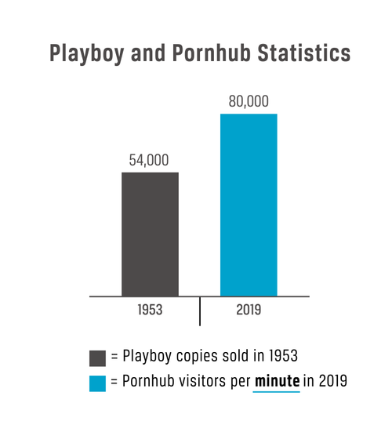

Contributing Factors
Addictive Nature of Pornography
A significant body of research does show that pornographic content has the potential to stimulate a user’s brain in ways that resemble addictive brain patterns.⁶³ People suffering from any type of addiction demonstrate a psychological phenomenon called incentive salience. A theory about brain function particularly relevant in describing the neural patterns of addicts. The theory suggests that “it is possible to ‘want’ what is not expected to be liked, nor remembered to be liked, as well as what is not actually liked when obtained.”. In other words, their desire to obtain certain “rewards” is detached from their actual enjoyment of those “rewards” (unlike non-addicted people whose desires for and enjoyment of “rewards” are proportionate). Problematic pornography users experience incentive salience. Many users feel heightened impulses to seek out the “reward” of pornography, but once it is obtained, the actual enjoyment of watching the pornography is lacking. This discrepancy is shown in a 2017 brain scan study. Participants with PPU scored higher than their non-PPU counterparts on “wanting” pornography: their reaction times to clicking a button that would give them a pornographic “reward” was quicker. But all participants (regardless of previous pornography usage) were roughly equal in their scores for enjoying the pornography; they all showed similar blood oxygen levels in the reward center of their brains.⁶⁴ This study suggests that people with problematic pornography usage experience incentive salience. A separate study corroborates that theory. Researchers found that individuals with “unregulated” pornography use (PPU) reported more negative attitudes toward pornography than individuals who used pornography frequently without out-of-control habits. According to the researchers, this supports the incentive salience theory because individuals with PPU are using pornography more but getting less fulfillment out of it.⁶⁵
General Addiction Cycle
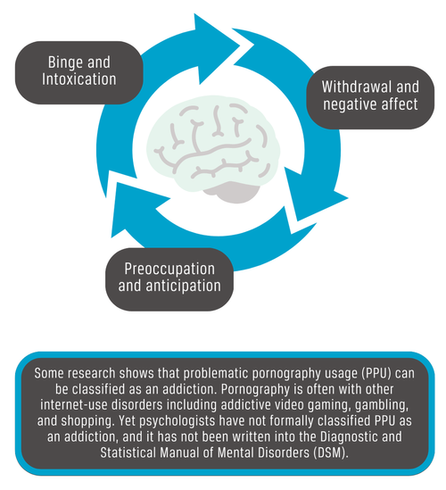
Though the effects of pornography have been controversial, science has correlated PPU with addictive brain patterns, making it dangerous for those who use it, which is especially true for people who are naturally impulsive or less functional at coping.⁶⁶ In the context of the recent COVID-19 pandemic, studies have found that there are drastic age-based differences in individuals' coping abilities. The research revealed that younger age groups are more vulnerable to stress, depression, and anxiety symptoms.⁶⁷ The lack of coping mechanisms increases young adults' addictive potential for PPU. Many people use pornography at “recreational” and manageable levels. But some users get trapped in addictive patterns, which perpetuates their usage and leads to negative consequences.⁶⁸

Ease of Access to Pornography
The spread of the world wide web allowed for an increase in both access and exposure to pornography among young adults. In 2021, 98% of pornography accessed by young adults was internet porn, with a majority (69%) viewed on a cell phone.⁶⁹ To illustrate how much people really view pornography on their cell phones, the data company Statista published that 20% of all mobile searches are for pornography.⁷⁰ These searches can easily lead viewers to what they are looking for as at least 4 million websites on the internet feature pornographic content. That equates to approximately 12% of all websites.⁷¹ The average internet user in the United States visits 130 sites daily.⁷² To put these statistics into perspective, if 1 person only visited pornography websites, it would take approximately 84 years to access all the pornography websites on the internet. Given that 93.6% of the US population uses the internet^{73,74} and that 88.6% gain internet access on a handheld smartphone,⁷⁵ the vast majority of people have pornography available to them regularly.
With pornography access facilitated, more young adults in America are intentionally consuming pornography through the internet. A cross-generational study examining pornography consumption over the last 40 years corroborates this: researchers surveyed men in various age cohorts and found that young adults in the mid-2000s consumed more pornography than young adults in the 1970s. Of the men who were 18–26 years old during the years 1973–1980, approximately 45% were classified as having consumed pornography in the previous year. Of the 18–26-year-olds in the 1999–2012 cohort, approximately 61% had consumed pornography, revealing a 16 percentage point increase.⁷⁶ This study also suggests that the invention of the internet most likely influenced the increase in pornography consumption—researchers drew this conclusion because they saw a 10% increase in pornography consumption from young adult males in previous decades to those in the 1990s (when the internet became popular).⁷⁷ Other research found that young people took advantage of increased access to internet pornography by using it for tips and ideas about how to have sex, as opposed to asking parents and friends for that information, which used to be the norm.⁷⁸
Apart from those who seek out pornography, many people get unexpectedly exposed to pornography due to the amount of explicit content that circulates online. One study reports that 93% of boys and 62% of girls were exposed to internet pornography during their teenage years.⁷⁹ Another study reports that of 9–19-year-olds, 57% came into contact with pornography online, and less than a quarter of those intentionally searched for porn.⁸⁰ More specifically young adults, of 18–19-year-olds, 80% saw porn, and only 26% reported that it was on purpose.⁸¹
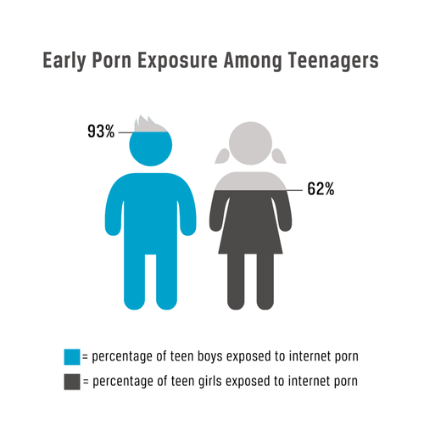
Some ways people are exposed to pornography without pursuing it include popup advertisements, junk mail, clicking on a pornography website, and receiving pornography from a family member, friend, or associate.⁸² Considering the addictive nature of pornography, unwanted exposure to pornographic content is problematic because it increases the viewer’s risk of developing a pornography habit.⁸³

The Lucrative Nature of the Porn Industry
The flourishing pornography industry serves as a catalyst for increased pornographic content, fueled by growing sales that motivate the creation and promotion of more content. According to IBISWorld, a company that analyzes commercial industries, the porn industry has experienced a 12.6% increase in revenue per year between 2018 and 2023.⁸⁴ In contrast, the sports industry only had a constant 6% increase in revenue during the same time period.⁸⁵ Like every other commercial sector, the desire for more recurring customers drives the pornography industry to provide a product that customers are willing to pay for, to market it to them, and to retain their business by maintaining customer interest in company goods and services.^{86,87} From a business standpoint, if the industry wasn’t lucrative, it would not exist. But considering that in 2023 the Adult & Pornographic Websites industry in the United States was on track to make $1.15 billion⁸⁸ (roughly matching the revenue of the NCAA⁸⁹ ), the porn industry is financially thriving and motivated to continue publishing pornography and pursuing customers.
Big-name pornography sites (like Pornhub) offer a limited amount of free porn, however, their monetized product is the purchase of monthly subscriptions that allow customers to access “premium” content.⁹⁰ These types of subscriptions can cost anywhere from $10–100 per month.⁹¹ One estimate claims that about 3.3 million people in the US pay for a pornography subscription,⁹² and according to a top-10-selling pornography website, 54% of new customers maintained their subscription after the first month.⁹³ It is subscriptions like these that fund the continued creation and advertising of pornography by big-name companies—the same pornography that is later accessed by billions of Americans on websites like Pornhub every year. Specifically, Pornhub saw 33.5 billion visits in 2018.⁹⁴
Other platforms for independent content creators such as OnlyFans employ slightly varied business strategies. Through these platforms, both amateur and professional content creators set up personal accounts and charge subscription fees anywhere from $5–50 a month to subscribers. Unlike bigger pornography companies, the performers on these sites keep 80% of the profit, which adds to the appeal of independent pornography creation.⁹⁵ Top content creators on Onlyfans are earning anywhere from $6–20 million a year.⁹⁶ As such, people are using their content: Onlyfans has 500,000 new users daily and 15 million new users monthly.⁹⁷
However, Onlyfans is not the only platform for independent performers. Many social media ⁹ Social media is a viable place for selling pornography because many US young adults use it: in 2021, 95% of young adults used YouTube, 71% used Instagram, 65% used Snapchat, and 42% used Twitter.⁹⁹ One study assessed the number of users selling subscriptions to adult content on Snapchat and found that over 11,000 Snapchat users were selling recurring subscriptions.¹⁰⁰ Alongside Snapchat, Twitter is one the most popular choices due to its permitting of explicit content in contrast to Facebook and Instagram.¹⁰¹ By posting pornographic content on social media platforms instead of keeping it concentrated on big-name websites, pornography saturates the internet.
The porn industry also uses business strategies to gain and maintain customers. For example, some pornography websites use the cookies and cache on an individual’s computer to alert other pornography distributors to their interests and preferences. This system of tailored advertising may contribute to a casual user transforming into an addict.¹⁰² Big pornography websites such as Pornhub also use a strategic and consumer-aware marketing strategy. Marketing strategists analyze consumer behavior and can see the hourly difference in website traffic due to external factors such as the launch of a new video game.¹⁰³ Also, during COVID-19, Pornhub made its content free to countries in lockdown.¹⁰⁴ The assumption is that by making pornography free during the lockdown, some viewers would choose to purchase a subscription later once the lockdown and free pornography ended. These tactics are just a few of the factors that contributed to the forecasted 15% compound annual growth rate for the online porn industry from 2022 to 2030.¹⁰⁵

Consequences
Because the research examines diverse populations, it cannot draw conclusions about what consequences an individual pornography user will experience. There are many factors defining a person’s likelihood of experiencing the consequences discussed here. Taken together, the data warns users of the possible negative effects of viewing pornography, which should be seriously considered before engaging with sexually explicit content.
Distorted View on Sex
People who use pornography put themselves at risk of developing distorted views of sex, which can harm their sexual well-being. In one study of young males ages 14 to 20, participants who viewed pornography reported self-consciousness about their ability to perform sexually. They expressed anxiety about their ability to perform to the extent and for the duration that porn stars performed.¹⁰⁶ When asked about their sex life satisfaction, approximately 41% of men who had not watched pornography the day before reported high satisfaction, whereas only 26% of men who had watched pornography during the same time period reported the same.¹⁰⁷ For young women, the research found that watching extensive amounts of sexual content on TV correlated with an increased chance of teen pregnancy. The survey specifically concluded that participants who were in the 90th percentile for watching sex on TV were twice as likely to experience teen pregnancy as participants who were in the 10th percentile. ¹⁰⁸ Pornography can also enforce attitudes of sexual objectification,¹⁰⁹ which can lead to increased sexual violence. One recent US study analyzed a sample of pornography videos for themes of male aggression and female submission. Results showed that 88.2% of the videos involved some type of rough sex (spanking, gagging, and so forth), and 49% of the videos showed the female actor complying with and enjoying the aggression.¹¹⁰ Other content portrays nonconsensual sexual aggression and even rape.¹¹¹ A study that examined the titles of pornographic videos on 3 popular pornography sites concluded that sexually violent content is advertised in the titles of 12% of all pornographic videos—that is 1 in every 8.¹¹²
The prevalence of violent pornography raises the question of whether or not those who watch violent pornography also engage in violent sex. Research found that violent sex depends on whether the viewer adopts the sexual scripts of the pornography,¹¹³ and it suggested that young people were susceptible to adopting sexual beliefs and ideas from the content they view.¹¹⁴ A developmental psychology study concluded that using pornography at a young age can increase a person’s likelihood of sexually harassing a peer or of forcing sex on someone.¹¹⁵ A 2019 study found that participants who reported a higher frequency of viewing pornography were more likely to have a history of engaging in rough sex and to report a higher desire for participating.¹¹⁶

Decreases in Emotional Health and Self-Image
A significant body of research correlates viewing pornography with lower emotional security. One study asking participants to self-report on their emotional health found that those who had watched pornography in the last 24 hours reported higher rates of loneliness (60%) compared to those who had never watched pornography before (38%). Other research has measured depression, anxiety, and stress among pornography users and non-users. One study, performed with over 1,000 college-age participants, concluded that compulsive pornography use significantly contributed to all 3 of those mental health measures.¹¹⁷
Other research suggests that the only aspect of one’s emotional health affected by pornography is the person’s self-esteem regarding their own genitals. Among 188 male community college students, those who reported more exposure to internet pornography reported lower satisfaction with the appearance of their penis.¹¹⁸ It is possible that watching pornography can decrease a person’s satisfaction with their overall appearance too, not just their genitals. In a survey published in 2022, 78% of participants who reported watching pornography in the last 24 hours reported unhappiness with their physical appearance compared to 44% of those who had never watched pornography and 58% of those who had watched pornography before, longer than the previous 24 hours.¹¹⁹
Research also found that heterosexual women whose partners use pornography experienced negative personal outcomes—revealing how pornography use by one partner has the power to influence the non-using partner. A 2012 study published in the journal Sex Roles reported that female participants who perceived that their male partners frequently or problematically used pornography scored lower on questionnaires assessing their self-esteem.¹²⁰ Another study suggested that female eating disorder symptoms can be influenced by a male partner’s pornography use. A study analyzing 409 women in heterosexual relationships found that current pornography use by their partners correlated with negative eating attitudes like dieting, bulimia, and food preoccupation.¹²¹
One set of researchers looked at the relationship between pornography use and religiosity, concluding that people of faith who hold morals in opposition to pornography risk developing barriers to their sense of identity if they use pornography.¹²² This is particularly true among adolescents and young adults who are still developing their sense of identity. Of young men ages 18–27, those who identified as pornography users scored lower on an assessment investigating their sense of identity, especially concerning their perception of how they fit into their families and what they want from dating.¹²³
Effects on Relationship Satisfaction
Pornography use by one or both partners has the potential to damage a relationship for several reasons. Research shows that when instigated between partners in a committed relationship, the arousal of sexual feelings is an integral part of keeping a couple united.¹²⁴ Pornography arouses sexual feelings, and when used in solo settings, it poses a risk to real-life relationships. An exploration of these risks proved that both men and women who viewed pornography solitarily reported significantly lower relationship satisfaction.¹²⁵
Data from over 600 married or cohabiting heterosexual couples showed that pornography affects relationships in different ways, depending on who is viewing the pornography. When the male in the relationship used pornography, both partners expressed negative impacts on their sexual experience. However, when it was the female, the quality of her sexual experience improved,¹²⁶ and in some cases, the male’s relationship satisfaction improved as well.¹²⁷ A meta-analysis of studies published 1978–2016 corroborates this, which concluded that if the male partner used pornography, the relationship was likely to experience adverse effects, but if the female used pornography, adverse effects were less likely to be statistically significant.¹²⁸
Divorce (or separation for unmarried partners) is the ultimate measure of relationship dissatisfaction. Among young adults specifically, divorce rates dramatically increased when pornography was introduced into a previously pornography-free relationship, and, as a conclusion, researchers opined that the relationship between pornography and divorce was correlational.¹²⁹ In a 2018 study, without pornography, a 20-year-old had a 6% chance of getting divorced or separated; with pornography, they had a 51% chance.¹³⁰ In comparison, a 40-year-old had an increased risk from 6–12% when pornography was introduced. The older a couple is, the less likely pornography is to influence whether or not they divorce; for young adults, the impact is significant.¹³¹
Adult Performer Effects and Abuse
The porn industry negatively affects more than simply the users of pornography; those on the other side of the screen must be considered. A “porn star” is slang for an individual famous for starring in pornographic films, however, within the industry, they are more commonly referred to as adult film performers. While the exact numbers of adult film performers are unknown, some estimate anywhere from 1,000–3,000 are in the United States alone.¹³² Porn actors are extremely difficult to track and research, resulting in a scarcity of data.¹³³ The lack of data could come from both ends of a social stigma; researchers are not seeking it and porn actors do not want to disclose personal information. Either way, it prevents research for understanding the gravity and depth of the consequences that adult film performers face daily.
One of the largest health risks that adult film performers encounter is contracting Sexually Transmitted Diseases (STDs). A study conducted in LA from 2004 to 2008 discovered that the rate of gonorrhea (STD) among adult film performers was 21% compared to 8% of peers not associated with the sex industry.¹³⁴ A 2012 AIDS Healthcare study found rates of gonorrhea and chlamydia (common STDs) are significantly higher among adult film stars in Los Angeles County compared to legal prostitutes in Nevada. The same research found that among LA county adult film performers, almost 30% tested positive for either gonorrhea, chlamydia, or both diseases.¹³⁵ This stark difference between Nevada and LA’s legal sex workers is simple: protection. Current laws regulate that in Nevada, condoms are required in all brothels.¹³⁶
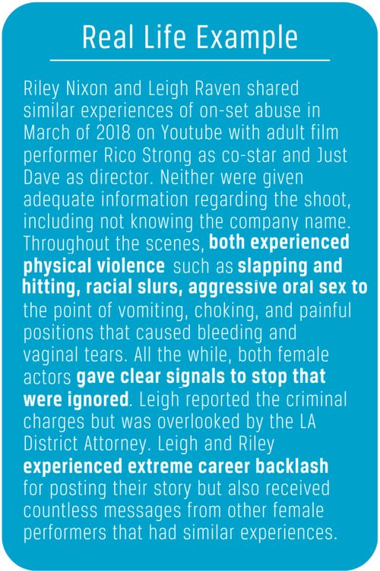
In California, however, there are no such regulations for the adult film industry.¹³⁷ A qualitative study interviewed 20 straight adult film performers who cited 3 possible explanations for the lack of condom use and regulation: perceived revenue decrease, the painful nature of actual condoms, and performer choice as possible reasons for the lack of condom use.¹³⁸ The belief was held by performers and directors that films that used condoms would not sell well and would hurt the bottom line of production. One actor said, “…to see a condom is just to ruin the fantasy. That’s part of reality. Porn is fantasy, so in fantasy, these borders don’t exist… It has nothing to do with the real world.”¹³⁹ A similar study found that while most performers enter the industry intending to perform protected sex, they soon find they must perform without condoms if they want to get hired, resulting in increased health risks.¹⁴⁰
Adult film performers also experience negative consequences from body enhancement. Female performers are more likely to undergo physically altering surgery compared to their male counterparts. In one study, researchers found that most female adult film performers got breast implants and some even had breast augmentations with the hope that it would increase the amount of time they would get in front of the camera. Male performers, on the other hand, were much more likely to use physically altering medication. They often felt the need to take medication or steroids to maintain an erection for longer scenes and to change their physical appearance.¹⁴¹
Adult film performers suffer from many mental, emotional, and drug-related consequences as well. A California-based study compared the mental health of female adult film performers and their peers. Their data showed that performers on average have 7.2 days of poor mental health in a 30-day span compared to only 4.8 days for those not in the industry. Over 30% of the female performers met the diagnosis of depression compared to 13% of the California Woman’s Health survey.¹⁴² Qualitative research cited that performers suffered from post-traumatic stress disorder, depression, bipolar affective disorder, and suicide.¹⁴³ Mental illness is extremely prevalent among female performers and is highly correlated to their work in the porn industry. Some entered the industry with a history of mental illness that was exacerbated while others developed them after entering the industry.¹⁴⁴
Another related consequence of being an adult film performer is the substance abuse that saturates the industry. Adult film performers cite many reasons for drug use including previous drug use, a large improvement in income, the new social network they’re thrust into, and coping with the emotional trauma of performing. On set, marijuana use was found highly prevalent among male performers while female performers often turned to drugs as a coping mechanism.¹⁴⁵
The poor spending habits and lifestyles of the adult film world have many financial consequences for the performers. One qualitative study that sampled 134 female performers, stated that in the past 12 months, 50% of adult performers reported living in poverty.¹⁴⁶ The universal definition of poverty is when an individual or community lacks access to resources for basic necessities to live a healthy and dignified life. As a result, individuals are unable to afford medical care or access to basics such as electricity, shelter, and food.¹⁴⁷ Among peers in the same region, the poverty rate was 36%, creating a large 14-point gap for actors in the porn industry.¹⁴⁸ This gap is due to the poor spending habits and lifestyles adopted by performers. Many performers spend their money quickly and are often in large amounts of debt, with no concept of saving.¹⁴⁹ One performer explained, “They go out there and party their money away, risk it all, do drugs, sniff it all up in their nose, because it all comes so fast and easy and they know the next day they can go and make $2,000.”
Inside the porn industry, female actors struggle to find safe agents. Many agents convince performers to go out for roles they do not feel comfortable with, with the understanding that it will put more money into their pockets.¹⁵⁰ Agents have been reported as desiring their client performers to stay at their houses where they provide everything, with the expectation that the client will sleep with them and their friends. One performer reported that she experienced this with 3 past agents.¹⁵¹ Producers have also been known to exploit female performers, some having required personal sexual favors prior to shooting, with the assurance that their agent had cleared it. Some performers even described boyfriends or husbands of performers that act as “agents” and exploit the girls in similar ways. They have been given the term “suitcase pimps” and are widely recognized in the industry.¹⁵²
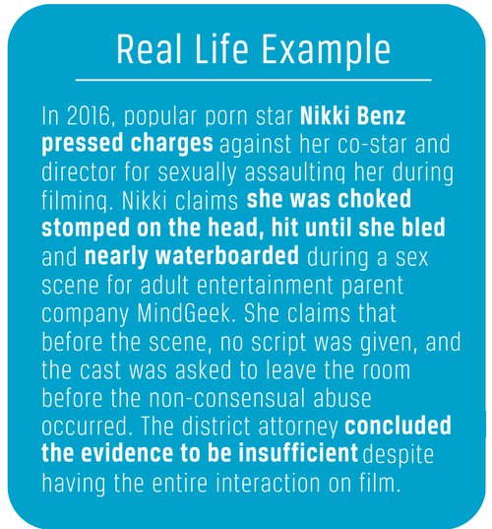
Abuse of all kinds is present and apparent in the Adult Film Industry, whereas prosecution and legal protection are close to invisible. Again, the data presented here represent female performers simply due to a lack of data on the male side. It is important to note that young girls (before even entering the industry) are more than twice as likely to have been victims of forced sex or rape. Studies showed that nearly 40% of female performers had experience with rape.¹⁵³ These adult film performers were also 5 times as likely to be placed in foster care and twice as likely to live in poverty.¹⁵⁴ Upon entering the industry, sexual violence and abuse only increased. Performers reported experiencing hair-pulling, choking, and consensual acts that injured them.¹⁵⁵ In 2011, 34% of female performers reported domestic violence and 27% reported forced sex and rape.¹⁵⁶ While not all pornography is abusive and violent, there are certain genres and companies where mistreatment is found more frequently. One Adult Film Company was reported to beating performers and shooting many scenes highlighting rape and harsh violence.¹⁵⁷
In addition to academic sources, there are also more personal and less academic sources that do exist about amateur pornography. One example is the work of Jill Bauer and Ronna Gradus, who, together, have directed and produced the documentary films entitled Sexy Baby (2012), Hot Girls Wanted (2015), and the documentary series Hot Girls Wanted: Turned On (2017). While these are not peer-reviewed sources nor research-based data, these are real girls with real stories.¹⁵⁸ In Hot Girls Wanted (2015) the film follows Tressa Silguero, Ava Taylor, Brooklyn Daniels, Ava Kelly, and Allie Rae in the amateur porn industry in Florida. They were recruited by “agent” Gavin Evans through Facebook ads with the promise of a free ticket to Florida. From the film, it is clear that there is no shortage of applications, as girls cycle through about every 3–6 months. The girls then lived together in-house and began creating an online following via social media.¹⁵⁹ Many girls experienced sexual health problems due to the excessive amount of sexual activity, dysfunction in familial and romantic relationships, poor mental health, emotional stress of being ridiculed by peers, as well as physical, verbal, racial, and sexual abuse experienced while on the job with coworkers and peers.¹⁶⁰

Practices

Pornography is a Social Issue
Pornography is often overlooked as a social issue due to users being unbeknownst of the negative consequences and its overall mainstream use. Improving and affecting social change is a multidimensional issue. The smoking pandemic of the 20th century illustrates how education and legislation can help to reduce social issues. In 1954, smoking in the US reached an aggressive high with 45% of Americans smoking weekly.¹⁶¹ However, only 7% of the population cited cancer as a negative health consequence of smoking.¹⁶² Just a few years later in 1964, percentages dropped to 16% smoking weekly.¹⁶³ Public opinion followed suit by the 1990s—90% of Americans believed smoking caused lung cancer¹⁶⁴ and ranked the tobacco industry among the most distrusted.¹⁶⁵ This drastic shift can be historically cited to show the impact that can occur through the release of medically-proven negative consequences, the spreading of public awareness, legislation and litigation changes, and the spread of preventative efforts.¹⁶⁶
It is the hope of many that what happened to the “cigarette century”¹⁶⁷ will likewise take place in the porndemic.¹⁶⁸ If a change in the community is to happen, pornography will need to be addressed from many different angles such as through academic sources proving pornography’s negative effects, changes in legislation, prevention efforts instigated for children, and support for those struggling with problematic pornography use.
This brief contains background context, contributing factors, and negative consequences regarding pornography. The following section outlines different organizations that are currently combating pornography from their unique angles: spreading awareness of negative effects, litigation and laws, prevention of early-age exposure, and addiction recovery resources.

Awareness
There are many organizations founded throughout the United States with the intent to raise awareness of the negative consequences of pornography and give support to those in addictive patterns, as well as to families of those struggling with pornography. Among young adults, one of the most popular organizations raising awareness is called Fight the New Drug. Their mission is to publicize scientific and personal data about the negative effects of pornography so that individuals can make an informed decision on how they will use it.
Fight the New Drug has published over 1300 articles on their website,¹⁶⁹ hosted over 90 episodes of a podcast called “Consider before Consuming,”¹⁷⁰ has 5.86 million followers on Facebook, released a three-part free documentary reaching thousands, put up over 100 billboards in San Francisco,¹⁷¹ collaborated with sports teams such as the Kansas City Royals,¹⁷² and reached over 30,000 youth through their “Porn Kills Love” presentations.¹⁷³

Litigation
Numerous organizations actively pursue legal action against the dissemination of pornography. One of the largest is the National Center of Sexual Exploitation (NCOSE), a nonpartisan and nonsectarian non-profit. NCOSE seeks to defend human dignity and oppose sexual exploitation.¹⁷⁴ NCOSE uses policy activism, public education and advocacy, training, research, legislation, and litigation. Much of NCOSE research links all forms of sexual exploitation and the public health harms of pornography. In its 60 years of operation, NCOSE has channeled its work into the following areas: pornography, sex trafficking of adults and children, sexualization of children, sexual assault and violence, child pornography, child sexual abuse, prostitution, violence against women, sexual addictions and compulsivity, sexually oriented businesses, sexual coercion, and image-based sexual abuse.¹⁷⁵
As a leading voice in the legal world, NCOSE filed the first class-action lawsuit against Pornhub for trafficking and child sexual abuse.¹⁷⁶ The NCOSE Law Center seeks justice for survivors of sexual exploitation by prosecuting companies with reports of abuse or exploitation. These organizations offer extensive support to survivor plaintiffs, actively engaging in litigation against the porn and sex trafficking industry. They serve as lead counsel or co-counsel, match clients with law firms, ghostwrite legal briefs, and facilitate the entire legal process.¹⁷⁷
2022 was a big year for impact at the NCOSE Law Center. In February 2022, one of many class action lawsuits, Doe #1 et al., v. MG Freesites LTD et al., led to the court rejecting MindGeek’s claim of immunity from liability under federal law. This ruling opened the door for other lawsuits on behalf of children whose images have been trafficked on internet platforms.¹⁷⁸
NCOSE is in the midst of multiple influential court cases. Williams et al. v. Sisolak et al., was the first time a federal court in Nevada permitted a case against a brothel and a strip club based on federal trafficking law to move forward.¹⁷⁹ Similarly, the Law Centers lawsuit John Doe #1 and John Doe #2 v. Twitter was the first lawsuit in the nation against Twitter on the assertion of immunity from liability that has not been dismissed. This case deals with Twitter profiting from sexual abuse images of young boys and if won could lead to holding many online platforms that traffic children’s images responsible.¹⁸⁰
Another big move came in the ongoing Doe 1-9 v. Murphy et al, against XHamster and MindGeek in which NCOSE served as co-counsel. This case deals with members of a college field hockey team that had been secretly filmed in the locker room changing. The footage posted was then uploaded and monetized on XHamster and Pornhub. The lawsuits emphasize the corrupt business practices and violations of the federal anti-trafficking law.¹⁸¹ These cases against big-name pornography proliferators are a manifestation of the mission, vision, and impact of the NCOSE Law Center.
In their 2020 impact report, NCOSE cited the launch of the international center on sexual exploitation (ICOSE) expanding its reach into England and Germany. The NCOSE Research Institute was also congratulated for its debut in seeking data-driven results to further NCOSE’s mission. NCOSE gathers leadership bodies containing 22,000 Advocates from 112 Countries. They also saw 16 states pass resolutions on the public health harms of pornography.¹⁸²
While the NCOSE covers exploitation in many forms from many angles, there are also gaps and limitations of the organization. Since the organization is mainly funded by contributions, gifts, and grants,¹⁸³ their reach and bandwidth are restricted to what they receive. Potential gaps that are unverified but censured include promoting misleading or unsupported false medical claims.¹⁸⁴

Prevention of Early Exposure to Pornography
Among the organizations helping to prevent early exposure and addiction to pornography is the organization Defend Young Minds. Their first book “Good Pictures Bad Pictures” sold over 270,000 copies from its year of publication 2014 to 2023 and was a #1 Amazon bestseller. This book had a 4.9/5 rating and 92% of its over 2,000 reviews said that this book was a vital tool for parents to teach their children the importance of treating their own and others’ bodies with respect.¹⁸⁵
Through additional books published since then, including curriculum for young families, their mission is to empower both adults and young children through the information and tools necessary to reject any sexual exploitation while young. Their goal is to keep an open dialogue about sexuality, body autonomy, personal privacy, and pornography from a young age in families. Governments and other organizations from around the world have found correlations between these candid conversations and reducing early, unwanted exposure to pornography.^{186,187,188} The belief is that kids who can have safe conversations about sex and pornography will be less likely to accidentally get involved with pornography before their minds are developed enough to choose to avoid it for themselves. However, it is difficult to measure the direct impact of these precautions because open and safe conversations are a prevention practice, not a mitigation intervention.^{189,190}
The impact of Defend Young Minds is found most frequently on an individual basis. Though there is a lack of longitudinal studies with children using the program, other longitudinal studies show the positive effects of education through safe family environments and schools. In one study, it was found that those who had witnessed intense, high-risk, sexual scenes through the media participated in sexually aggressive behaviors 4 times as intense as those who had not seen pornography.¹⁹¹ Considering that it was reported that 85% of young people have seen or have been exposed to pornography and yet 62.62% reported not having had any sexual education concerning pornography, we believe that more education such as what Defend Young Minds is offering can make a significant impact on how children respond to their unintentional exposures.^{192,193} Another study supported this, concluding that the more parents and children have open communication about sexual health issues including pornography, children are more likely to make better decisions about sex.¹⁹⁴
A significant gap for organizations such as Defend Young Minds is that they have built their content for parents to present to their children in the home. However, some households are not safe places children can use to navigate these complex issues. Because of this, children go to other sources. For example, it was found that for gay and lesbian young adults, the internet has become a safe place to self-examine and educate themselves over uncomfortable issues such as pornography.¹⁹⁵ With this in mind, Defend Young Minds could add an online chat feature where children and teenagers have a safe site to discuss their feelings and learn more about sex.

Pornography Addiction Resources
For anyone who wants to reduce or end their pornography habits or help a loved one in their negative pornography habits, resources exist to assist them on their journey. Whether a person considers themself compulsively addicted to pornography or not, reducing the amount of pornography they consume is a behavioral change that can be aided by resources ranging from self-help books to recovery support groups. Research on the effectiveness of such resources remains scarce and varies from resource to resource.
Fortify—A free, self-guided recovery plan that includes educational material about the science and psychology of a person’s pornography habit, a digital platform for tracking pornography use over time, and an accountability partner to provide support and encouragement along the way.
The Journey Course—A for-purchase, “5-month path to freedom from sexual brokenness for men and women,”¹⁹⁶ which includes help for those with compulsive pornography use. This course, run by a mental health coach who is also an ordained minister, attempts to uncover each individual’s unique triggers that cause unwanted sexual behavior.
The Church of Jesus Christ Addiction Recovery Program—Organized support groups on all 6 inhabited continents provide fellowship for anyone seeking to overcome addictive behavior, including pornography addiction. Though sponsored by The Church of Jesus Christ of Latter-day Saints, these support groups are available to anyone in the community and are non-denominational.
The Ranch Tennessee—An in-house treatment center for those seeking to overcome more serious pornography addictions. This center simultaneously treats mental health disorders that commonly co-occur with addiction, such as anxiety disorders, clinical depression, obsessive-compulsive disorder, and borderline personality disorder.
SAMHSA’s National Helpline—A free hotline that provides immediate verbal support about any mental health crises—including the mental and emotional struggle to overcome pornography use. It operates 24 hours a day, 7 days a week in both English and Spanish.

